User Acceptance Testing (UAT) Template
TEAM ID | LTVIP2025TMID32045
PROJECT NAME | SB Stocks is a user-friendly web app built for stock market enthusiasts
MAXIMUM MARKS
Project Overview:
Project Name: [Enter Project Name]
Project Description: [Brief Description of the Project]
Project Version: [Version Number]
Testing Period: [Start Date] to [End Date]
Testing Scope:
[List of Features and Functionalities to be Tested]
[List of User Stories or Requirements to be Tested]
Testing Environment:
URL/Location: [Web URL or Application Location]
Credentials (if required): [Username/Password]
Test Cases:
Test Case ID | Test Scenario | Test Steps | Expected Result | Actual Result | Pass/Fail
TC-001 | [Describe the scenario to be tested] | [Step 1]  [Step 2]  [Step 3] | [Describe the expected outcome] | [Record the actual outcome] 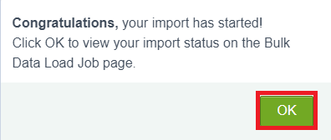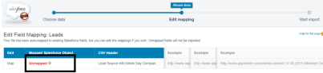 | [Pass/Fail]
... | ... | ... | ... | ...  | ...

Bug Tracking:
Bug ID | Bug Description | Steps to reproduce | Severity | Status | Additional feedback
BG-001 | [Describe the issue or bug encountered] | [Step 1]  [Step 2]  [Step 3] | [Low/Medium/High] | [Open/In Progress/Closed] | [Any additional comments or feedback]
... | ... | ... | ... | ... | ...

Sign-off:
Tester Name: [Name of Tester]
Date: [Date of Test Completion]
Signature: [Tester's Signature]
Notes:
- Ensure that all test cases cover both positive and negative scenarios.
- Encourage testers to provide detailed feedback, including any suggestions for improvement.
- Bug tracking should include details such as severity, status, and steps to reproduce.
- Obtain sign-off from both the project manager and product owner before proceeding with deployment.

